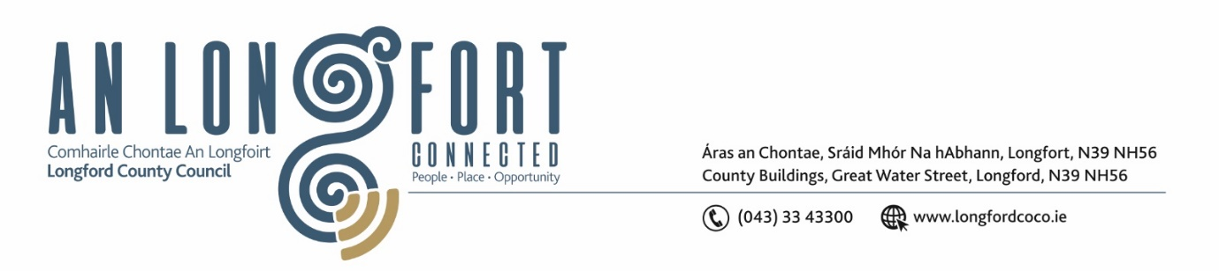

***Please note meeting will be held in the Council Chamber and via Microsoft Teams.***

6 November 2024

**Chuig: Gach Ball don Chomhairle**

A Chomhairleoir,

Iarrtar ort bheith i láthair ag Cruinniú Míosuil Chomhairle Chontae Longfoirt a tionólfar i Seomra na Comhairle, Aras an Chontae, Longford agus via MS Teams are an **Chéadaoin 13 Samhain 2024 ag 4pm** chun gnó a dhéanamh d’réir an Chláir thíos.

You are requested to attend the Monthly Meeting of Longford County Council to be held in the **Council Chamber and via Microsoft Teams** on **Wednesday, 13 November at 4pm** to transact business, as set out on the Agenda hereunder.

Mise le meas,

**__________________**

***Claire McNabola***

***Meetings Administrator***

**C L Á R**

Prayer before meeting.

1. **Confirmation of Minutes**
2. Monthly meeting of Longford County Council held on 09 October 2024 – enclosed.
3. **Matters Arising**
4. **Declaration of Interest by Members**
5. **To note Management Report**
6. **Housing, Planning, Regeneration & Capital Projects**
7. To note planning applications received
8. **Notice of Motions set out hereunder:**

Councillor Garry Murtagh

1. I call on Longford County Council to write to the Minister for Housing Darragh O’Brien and the Office of Planning Regulator CEO Niall Cussen regarding the high housing density per hectare in rural towns such as Longford. Small towns such as Longford do not have the infrastructure, resources, or economic opportunities to support high density housing. Instead of supporting the housing crisis it is creating the ghettoization of small towns isolating the marginalized and further compounding the socioeconomic problems that exist in our County.
2. I call on Longford County Council through the Social Development Strategic Policy Committee with responsibility for Housing to develop a policy/scheme where void/vacant Longford County Council properties can be sold to people with insufficient mortgage offers of finance from two regulated financial providers. In turn providing people with limited access to financial support, the opportunity to purchase, renovate/retrofit by means of the Local Authority Purchase & Renovation scheme and the Croi Conaithe Grant to activate their dreams of a forever home.
3. **Community, Library and Cultural Services, Corporate Services**
4. Consideration of Draft 2024-2029 Corporate Plan (attached)
5. Approval of the appointment of Ms. Caroline Cornally, nominee of Longford and Westmeath Education and Training Board as a member of Longford Local Community Development Committee (LCDC).
6. Approval to the appointment of Sectoral Representatives to the Strategic Policy Committees (see attached).
7. Consideration of Strategic Policy Committee Standing Orders 2024-2029
8. Consideration of application from Longford Women’s Link for a group visit to Longford County Council Civic Buildings.
9. **Votes of Sympathy**
10. **Date and time of next Meeting**